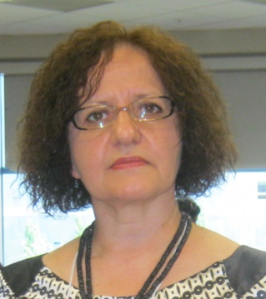

Vera Savic, MPhil, is Lecturer in English Language and ELT Methodology at the Faculty of Education in Jagodina, University of Kragujevac, Serbia, where she is currently teaching academic courses of EGP, ESP, EAP, TEFL, TEYL and Methodology Practicum of TEYL. She has completed her professional development in TEFL at the University of Essex, Great Britain, and in TEYL at the University of Maryland, Baltimore County, Maryland, the United States of America. Her main research activities are focused on applied linguistics (she is a member of AILA Early Language Learning Research Network), teaching English to young learners (TEYL), developing reading skills, initial teacher training, continuous professional development (CPD) of EFL teachers, theme-based instruction (TBI) and inclusive language teaching. She has published dozens of papers and presented at international conferences in the country and abroad. Moreover, she has initiated a biennial international conference on TEYL at the Faculty of Education in Jagodina, Serbia, and has been on the conference programme committee of all four conferences so far.

